**HUMAN COMPUTER INTERACTION (CSC 441)**

**GROUP 1**

TITLE:

**DESIGN OF AN INTERACTIVE LEARNING SOFTWARE**

LECTURER IN CHARGE:

**MISS ANUONYE. C**

**TEAM MEMBERS**

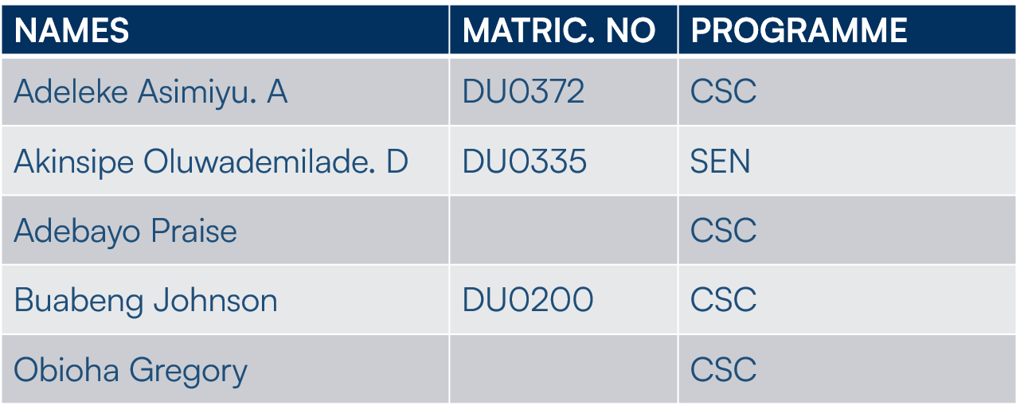

**MEET THE TEAM**

|  |  |  |
| --- | --- | --- |
| **S/N** | **NAMES** | **ABOUT** |
| **1** | Adeleke Asimiyu. A | Computer Science student with a major background in graphic and interaction design, particularly in creating intuitive interfaces. |
| 2 | Akinsipe Oluwademilade Daniel | Software engineering major with expertise in web development technologies. He has a keen interest in user experience in educational settings. |
| 3 | Obioha Gregory. C | Studies Computer Science, with background in data analytics contributes robust technical and analytics skills. |
| 4 | Adebayo Praise | Computer science student. Assisted the group financially in terms of data and other supports. |
| 5 | Buabeng Johnson | Studies Computer Science, with some background in designing. Helped with survey questions and observation documentation. |

**DESIGN MOTIVATION**

The motivation behind this design is to enhance the specific learning journey of those students by addressing their unique educational needs and challenges. Since the app is tailored primarily to Dominion University, we have the opportunity to align it closely with the school's curriculum, teaching methods, and learning goals. We can also incorporate features that foster collaboration among classmates and strengthen the teacher-student relationship. The ultimate goal is to make learning more personalised, engaging, and impactful for students while complementing the school's educational vision.

**DATA GATHERING**

1. **Interviews:** Conducted with both students and educators to explore current pain points in online learning, such as lack of engagement or difficulty in navigation. Sample questions included “What features do you find most engaging in a learning app?” and “How can digital platforms better support your learning process?”
2. **Questionnaires:** Distributed to a wider audience to gather quantitative data on user preferences regarding interactive elements, ease of navigation, and overall learning experience.
3. **Observation:** Observed students using existing educational platforms to note how they interact with digital learning tools and where the breakdowns in user experience occur

**PILOT STUDY**

We initiated our study with a pilot group of five participants:

**Interview Questions**

* Can you describe your current experience with online learning platforms? What aspects do you enjoy or find frustrating?
* How do you typically navigate through a digital learning interface? Are there any features that help or hinder your experience?
* What types of interactive elements (such as quizzes, discussion forums, or multimedia content) do you find most engaging in an educational app?
* Can you share an example of a feature or tool from another learning platform that significantly improved your experience?
* What challenges or obstacles have you encountered when using online learning tools, and how do you usually overcome them?

**Pilot Findings**

Early feedback revealed that learners crave a balance between content delivery and interactive elements. This insight led us to incorporate more dynamic features like interactive quizzes and live feedback sessions into our design concept.

**Impact of Pilot Findings**

The pilot study validated our approach and prompted adjustments in our data collection instruments to better capture specifics related to interactive learning experiences.

**MAIN FIELD EXPLORATORY STUDY**

1. **Participants:** We expanded our study to include 30 participants from Dominion University, spread across two faculties in the institution. The demographic comprised 17 males and 13 females, with an average age of 18 years. All participants were active users of digital educational platforms with an average of 3 years’ experience in using technology for learning.
2. **Recruitment & Compensation:** Participants were recruited through purposive sampling, ensuring a mix of students and educators. We were unable to compensate them with tangible gifts, but we thanked and appreciated their cooperation.
3. **Data Collection Tools:** For data collection, we utilized:
   * Jotters for interviews.
   * Online survey tools notably Google Forms for questionnaires.
   * Observations were documented on paper and shared among members.

**ANALYSIS OF OTHER WEB-BASED PLATFORMS**

|  |  |  |  |
| --- | --- | --- | --- |
| S/N | Website | Strengths | Weaknesses |
| 1 | Khan Academy | Structured curriculum | Limited interactivity in quizzes. |
| 2 | Quizlet Live | Collaborative games | No offline mode. |
| 3 | Coursera (Young Learners): | Video integration | High cognitive load |
| 4 | Duolingo for Schools (Web) | Gamification | Repetitive tasks. |
| 5 | Codecademy | Hands-on coding | Steep learning curve for younger users. |

* : Strengths –; Weaknesses –

**ANALYSIS OF RESPONSES:**

Our thematic analysis uncovered several key insights:

* **Engagement Drivers:** Learners emphasized the importance of interactive content such as quizzes, real-time feedback, and multimedia elements.
* **Navigation & Usability:** A clear, intuitive interface was critical for maintaining engagement and ensuring ease of access to educational resources.
* **Customization:** Users expressed a desire for personalized learning paths that adjust based on their progress and interests.

**Reflections**  
Our data gathering process highlighted the necessity of blending traditional educational content with innovative interactive elements. The iterative process—starting from pilot studies to comprehensive field observations—allowed us to refine our design to truly reflect user needs and preferences in an interactive learning environment.

**CONCEPTUAL/USER MODEL:**

1. **Personas:**  
   We developed three key personas:

* **The Motivated Learner:** A student who thrives on interactive, gamified learning experiences and values real-time feedback.
* **The Traditionalist:** A learner who prefers structured content delivery with clear navigation and straightforward layouts.
* **The Collaborative Educator:** An instructor who values tools that facilitate discussion, content sharing, and collaborative learning.

1. **Metaphors:** To make the learning process more relatable, we adopted metaphors such as “classroom dashboard” and “learning pathway,” echoing familiar educational settings.
2. **Interaction and Interface Type:** The design emphasizes a hybrid interface that combines intuitive navigation with interactive modules. Key features include touch-friendly elements, dynamic content updates, and integrated multimedia resources tailored for an online learning environment.

**STORY BOARD**

1. A user at her computer typing in the web address.
2. She either signs up as a first-timer. Or logs in as an existing user.
3. She explores the homepage full of several course modules
4. She selects a course module and enters the main course page
5. She engages with an interactive video lesson
6. She participates in interactive quizzes related to the course content
7. She reads and responds in a discussion forum with other learner
8. She receives a completion badge for finishing a module
9. She smiles feeling accomplished and satisfied

**USER AND TASK DESCRIPTION**

Primary tasks involve:

* + Registering and creating a personalized profile
  + Navigating through course modules
  + Participating in interactive quizzes and live discussions
* Accessing supplementary learning materials and providing feedback

Each task was analysed to ensure that the learning experience remains seamless and intuitive.

**DESIGN REQUIREMENTS**

Based on our findings, the design must:

* + Offer a simple, intuitive, and engaging user interface
  + Support multimedia content and real-time interactive features
  + Provide personalized learning pathways
  + Include robust feedback and discussion tools for both students and educators
  + Maintain high performance and responsive design across devices

**PRELIMINARY FINDINGS**

|  |  |
| --- | --- |
| **Validated Assumptions** | **Invalidated Assumptions** |
| Our research confirmed that interactivity, personalized content, and clear navigation are critical for enhancing the online learning experience. The demand for real-time feedback and engaging multimedia elements was particularly strong. | We initially assumed that users would quickly adapt to complex interactive features. However, our study showed that a simpler, more intuitive design is preferred by the majority of learners. |

**Behavioural Patterns**

* + Users tend to explore learning platforms non-linearly, often skipping between modules
  + High value is placed on instant feedback and clear progress tracking
  + There is a strong preference for platforms that mimic the structure of a traditional classroom while offering digital interactivity

**SITE MAP**

